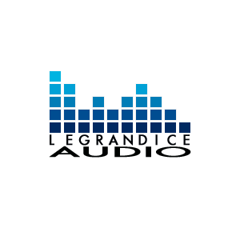
8 Roundelay Rd.
South Hadley MA 01075
413.536.8423
www.legrandice.com

legrandice audio will be professionally recording every major GHS Music Department performance this year. You may pre-order recordings for the entire year at a discounted rate if you purchase before the 1st concert of the year.

Parent Name____________________ Student Name_____________________

Parent Email_________________________________________________________

I would like to pre-order all mp3’s for the 2019-20 school year for the following ensembles: ($25 per ensemble)

___ Concert Band ___ Repertory Orchestra

___ Wind Ensemble ___ Voices

___ Jazz Ensemble ___ Concert Choir

___ Symphony Orchestra ___ Mixed Chorus

Total ensembles Ordered ____ X $20 = Total Enclosed: $__________.
Personal checks are welcome, payable to GHS Music Boosters.

You will receive e-mail confirmation of your order in 1-2 weeks, and you will receive instructions on how to download recordings after the first performance.

